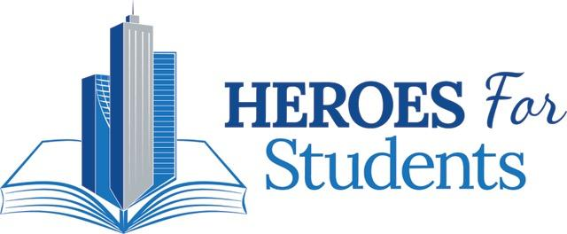

Project Report

HEROES For Students Foundation

|  |  |
| --- | --- |
|  |  |
|  |  |

Charles Brown, Arick Hanna, Tom Sharp, Ed Sharp, William Sugihara

Team members

Table of Contents

**Cover...................................................................................................... 1**

**table of contents.................................................................................... 2**

**Introduction.......................................................................................... 3**

**Website Design..................................................................................... 4**

**Website Testing.................................................................................. 10**

**Waffle IO............................................................................................ 16**

**Final Website..................................................................................... 18**

**GitHub................................................................................................ 24**

**Conclusion.......................................................................................... 25**

Introduction

HEROES for students was founded by Chris Reina and Richie Ressel as a non-profit foundation. HEROES operates as a standards-based classroom curriculum supplement and online platform for networking K-12 teachers to guest speakers from the community to apply students' academic content to the real world. Part of getting their foundation going was the creation of their web presence. This was done previously by ASU students working on their capstone project. The final product was successful in providing HEROES for students a web platform for teachers and community business leaders to connect. In order to moved the foundation forward, Mr. Reina and Mr. Ressel decided their website needed a complete overhaul in terms of the layout and design. They were happy with the basic functionality and the backend they selected to store registered users information, but they wanted their website to have a modern look to it. After meeting with Mr. Reina we received a list of items to update or change on the HEROES for students website along with an initial due date of March 4th. The list included updating the look of the website to a more modern appearance, creating an animation that described what HEROES does in 30 seconds, and adding features such as slide shows, news feeds and improved content management. We then assigned priorities to the changes items and determined which items will be completed by March 4th. As we proceeded with the project we met with the client every two weeks prior to the milestone due dates to ensure the changes were aligned with their vision. The following is a detailed explanation as to what each milestone included for this project, and a brief description as to what items remain for a possible future project.

Website Design

After our team had its first meeting with the client we had a good idea of what was desired initially. Our client Chris wanted to make his website more aesthetically pleasing for users so that they would be more inclined to use their website. He compared the look he wanted to that of the “Teach For America” webpage so we had a good example to start from. Chris found the current state of the website to be boring and bland.

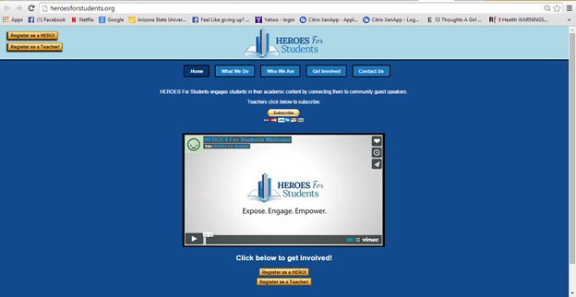

Initially there was already Java, php, html and css code working for the website. There were ‘include’ files but the problem was with the JQuery file. There was only one file and in that file were several functions that were being used for the HEROES site. The issue was that no one on our team had experience working with JQuery. Charles attempted to understand the code and how it drove the different aspects of the code for the website but it was taking too long in the amount of time that was given (spring semester at ASU). So the team discussed it and made a decision to start from the bottom up without using the JQuery code, although some of the original code was still implemented for the current site.

The first task was to redesign the home page and thus every page in the website. Every team member worked on a design for the site except for William as he was working on developing the animation to explain what the site does. After submitting various versions of the website it was decided that the design that Ed and Tom came up with would be implemented. From this stage we assigned ourselves tasks and a deadline for completion so that we could have something to show to the client and to present for our milestone. One of the first iterations of the website can be seen below:

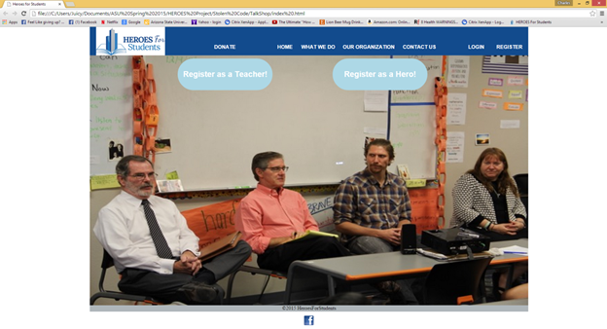

This iteration had the Registration buttons over the photo on the main page. There only one fixed photo and the menu bar was above the photo and a dark blue color that was part of the HEROES color scheme. The above iteration was the version created by Arick before we decided to go with what Ed and Tom had which was implemented in milestone 2. Milestone 2, which was released on February 13, included photo slide implementation; animation development and navbar/index development which reflected our efforts to produce a final style to begin functionality work on. This milestone also had a ReadMe File on how to access and edit files. We had planned on having social media interaction between the HEROES website and others such as LinkedIn and Facebook but we discovered that LinkedIn had changed their rules and would not allow businesses or organizations to have an account without paying a fee.

Milestone 3 release included more functionality with going from page to page and playing video as well as adding a scheduling link to Time Trade so that users could coordinate times on a calendar. HEROESforStudents.org was tested for functionality by teachers at William’s workplace. This was valuable as we could get genuine feedback from the type of targeted users the website was intended for. Milestone 4, which was released on March 13, involved us looking back at our challenges, progress and goals and putting that in a video. The video illustrates what we initially were presented with by the client, the client’s requests for the website and the state of the HEROES website at that point. On March 4 our client had a presentation and needed the website to be functional enough to register users at the presentation but also needed it to look good. Our team was able to deliver a functional and modern looking website compared to what we began with and our client informed us that the presentation was a huge hit! Although this was a major accomplishment for our team we realized we still had significant work to do before we would hand-off the website to the client. In the fifth milestone release the additional requests and changes that Chris requested were in development. We were working on content for the pages, a news feed for articles of interest, photo structure and text format were among the final requests we worked on.

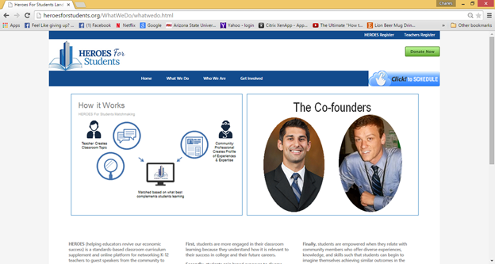

There were setbacks and work-arounds made throughout development of the website. The animation that was created was having issues rendering/playing from the video file on the GoDaddy domain so the file was uploaded to Vimeo and the lightbox photo and video window application integrated into the What We Do page was pointing to the URL for the video on Vimeo. There was a lot of time spent editing the animation video before the first release and more revision afterwards. The look of the website evolved from having jpg buttons for the ‘donate’ & ‘Time Trade’ buttons to a simpler button structured to blend in better with the look of the website.

Our client wanted to be able to update content on the website or to be able to rely on someone else to do so and requested that instructions be made specifying how content on the website can be updated. It was decided that a procedure should be made in order to ensure that the client had reliable documentation for updating relevant content on the HEROES website pages. To make it more user friendly a table of contents was added to the procedure so that users could use the hyperlink chapters to quickly get to the appropriate procedure.

Table of contents for procedure manual

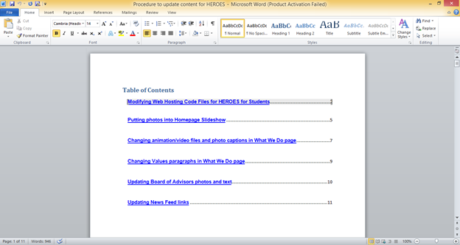

Procedure for updating website

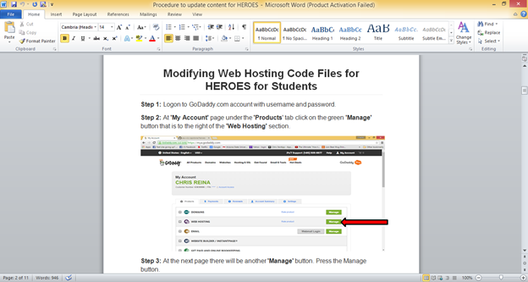

Hyperlinking chapters for procedure manual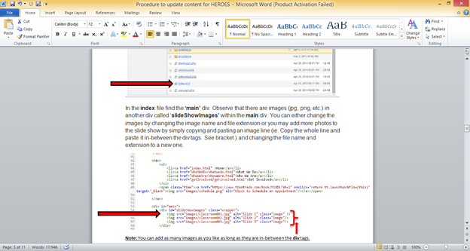

Testing

For milestone 6 we used Selenium IDE to test the functionality of our website. Tests we did included full functionality of the website and the buttons, each of our videos on the what we do page, functionality of buttons on the who we are page, functionality of the buttons and picture links on the get involved page including the email portion, and functionality of both of the signup forms. Also all the tags, jQuery calls and jQuery libraries were tested.

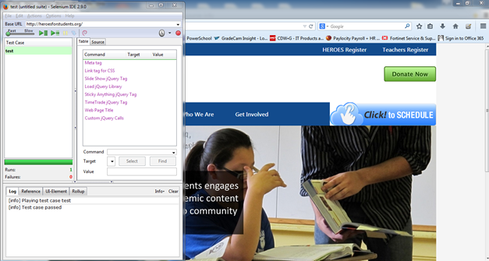

Test 1: This test was performed to check all Tags, jQuery calls and libraries.

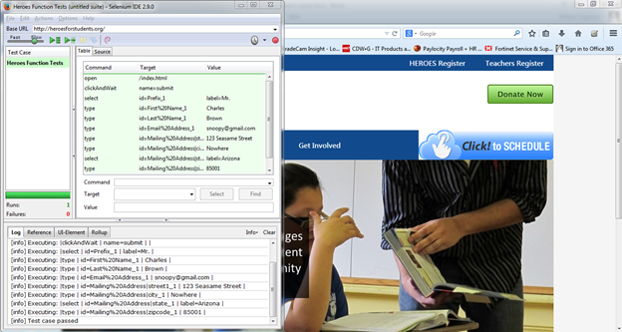

Test 2: This test to see if ‘Donate’ button on the Heroesforstudents.org Home page will work and also inputting of data into the fields to assure functionality.

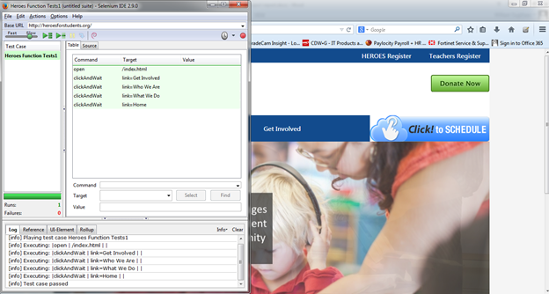

Test 3: This test to make sure navigation from Home Page>Get Involved Page>Who We Are Page>What We Do Page>Home Page is successful.

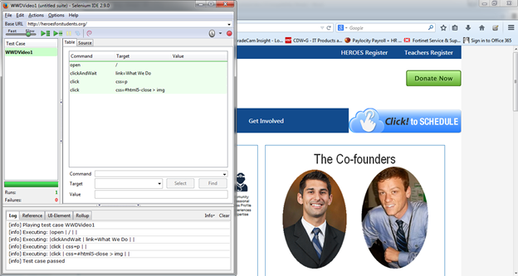

Test 4: This tested the animation video on the “What we do” page.

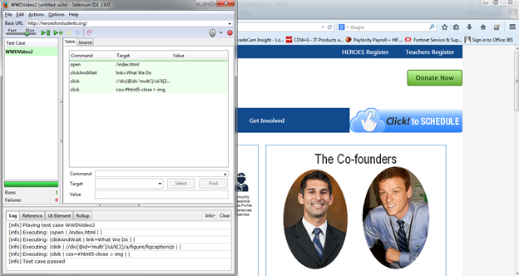

Test 5: This tested the About HEROES video on the “What we do” page.

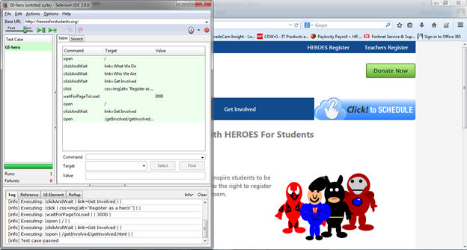

Test 6: This test checked the HEROES registration link on the “Get Involved” page. It successfully linked to the Google Docs page for HERO registration.

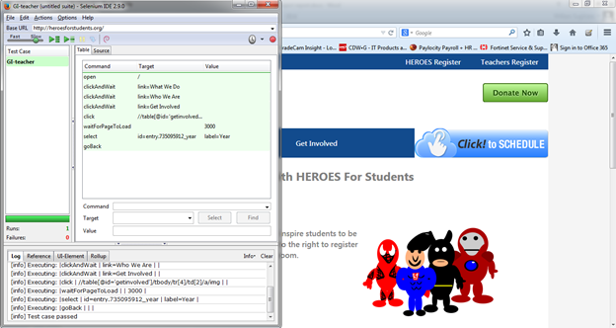

Test 7: This test checked the Teacher registration link on the “Get Involved” page. It successfully linked to the Google Docs page for teacher registration

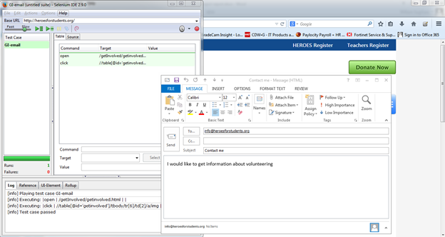

Test 8: This test checked the email link functionality for the “Volunteer” link on the “Get Involved” page. It successfully open up the default email client and filled in the “to” address, subject and a brief message asking for more information.

The last two tests show as “failed” but they are not really failures. Selenium has an issue with delays or waiting sometimes. So they list the test as fails even though they performed as required. We researched this issue when performing these tests and it appears that it is a very common problem. We have since researched this issue further and it seems related to the fact that “clickandwait” was trying to perform its action on a pop up element. It was recommended the test be switched to “waitFor” element command. Either way, other tests confirmed that the link is working so for our purposes a new test was not required.

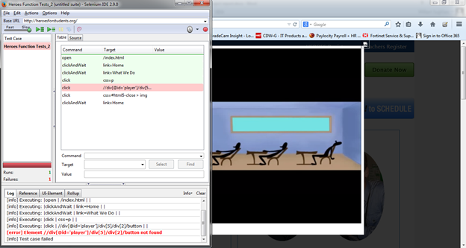

Test 9: This test shows that the animation video failed, but as you can see it passed. Selenium had some issues with waiting between commands when the element selected is a pop up.

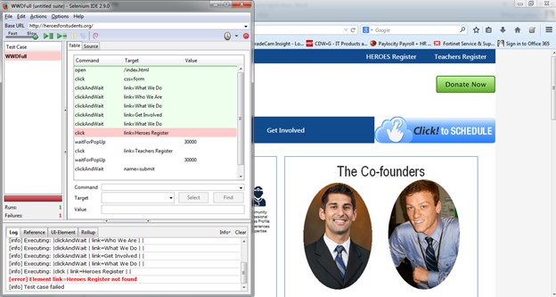

Test 10: This test checked the full website functionality. It shows the HEROES register link as failed, however as other tests have shown this link works fine.

Waffle IO

Throughout the life of our project we decided to use waffle.io as our task board. The task board was able to help us visualize what needed to be done currently as well as what was anticipated to be done in the future. It also helped us divide the tasks appropriately between group members. Since it could be accessed by every group member, once someone finished a task they could go in and move their task to done as a notice to the group members that the task is finished. The option to input comments on each task was also a tremendous help. If we had any questions that needed to be answered or if we needed help we would write comments on the task in question. The biggest problems we had with the task board was not updating it after we finished a task. Since we all had a good understanding of the tasks we needed to accomplish, this didn’t affect us much. We communicated very well in person, by email, and by text to discuss what was ready to be implemented, what was in progress and what we had finished. The task board was mainly there as a visual for us so we could go back to it and see if we had forgotten anything. Our client was also very helpful at keeping us on track. During every in person meeting we had, we would come up with the tasks that needed to be done and assign each task to a group member. We would then write an email to the client and each group member listing the tasks and who was responsible for each task. This gave us a visual on what needed to be accomplished and we could then add those tasks to our task board as well.

Our Waffle IO dashboard

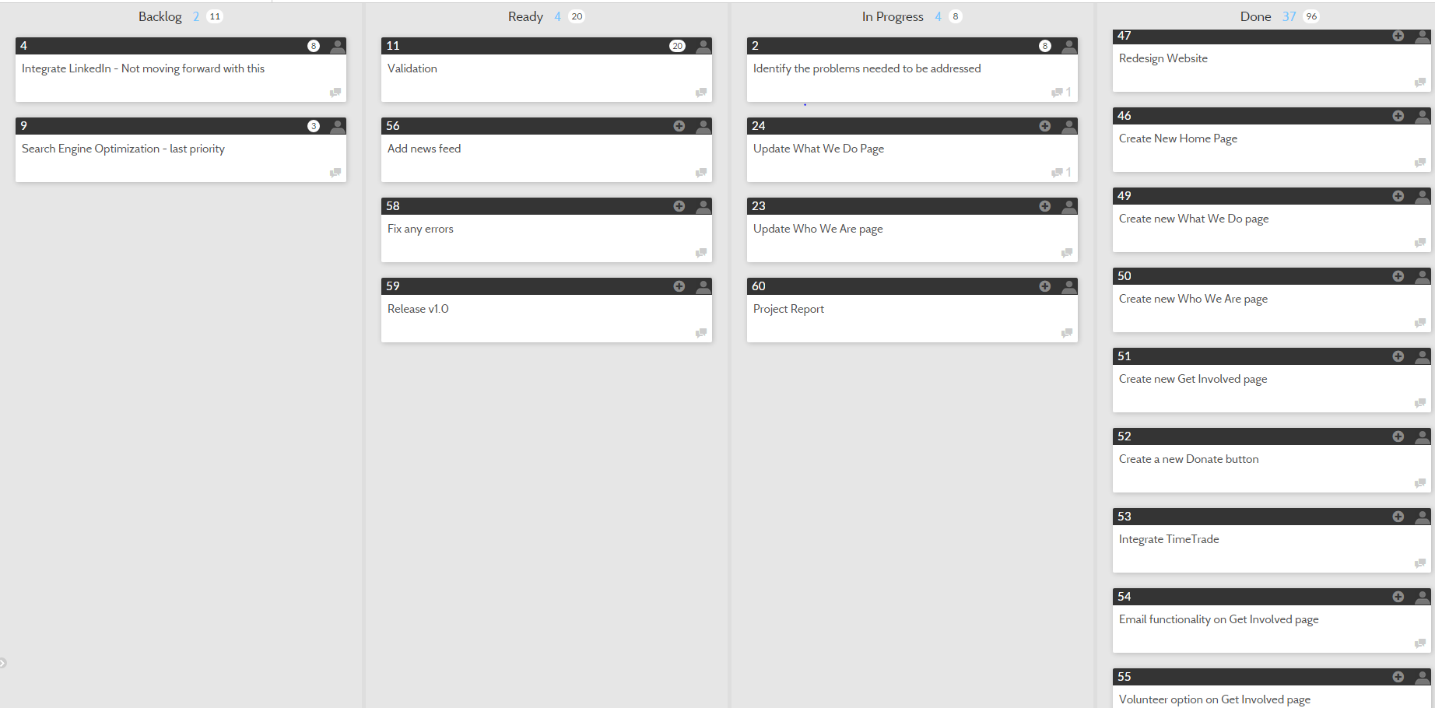

Screenshots of Final Website

Home page with slideshow

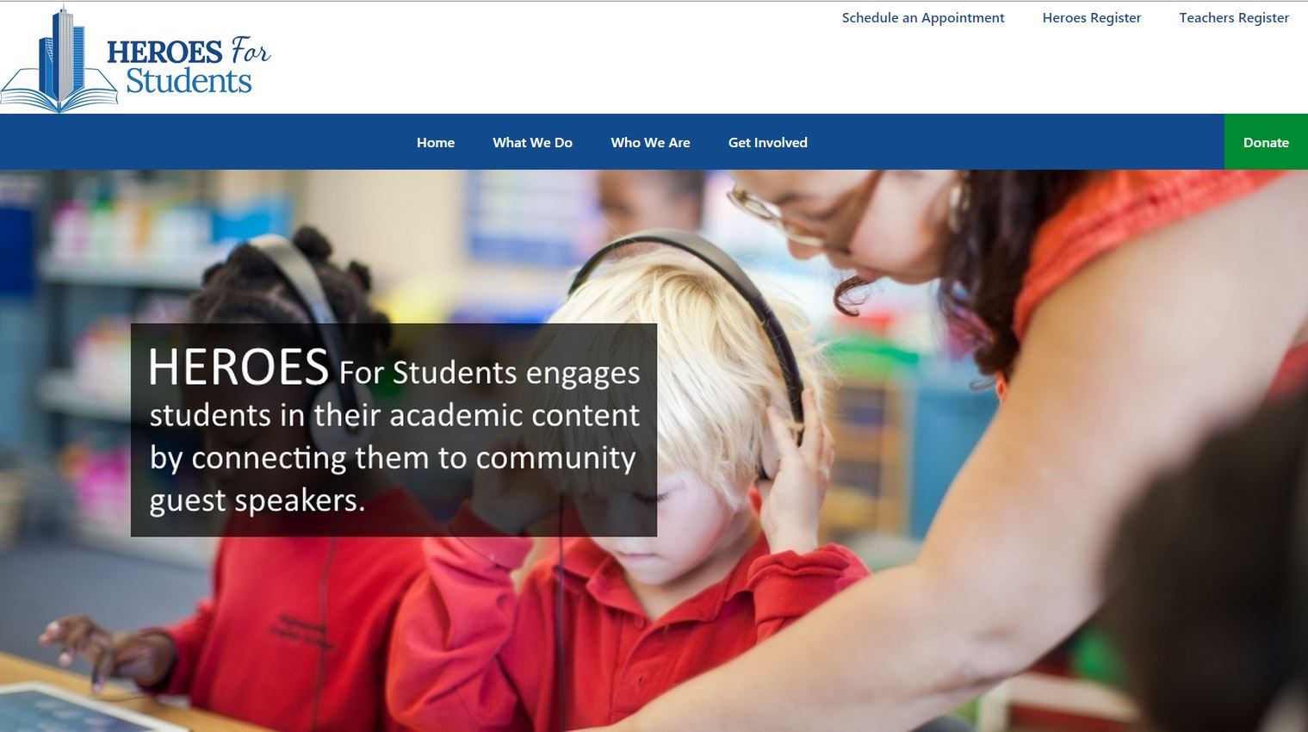

Home page news feed

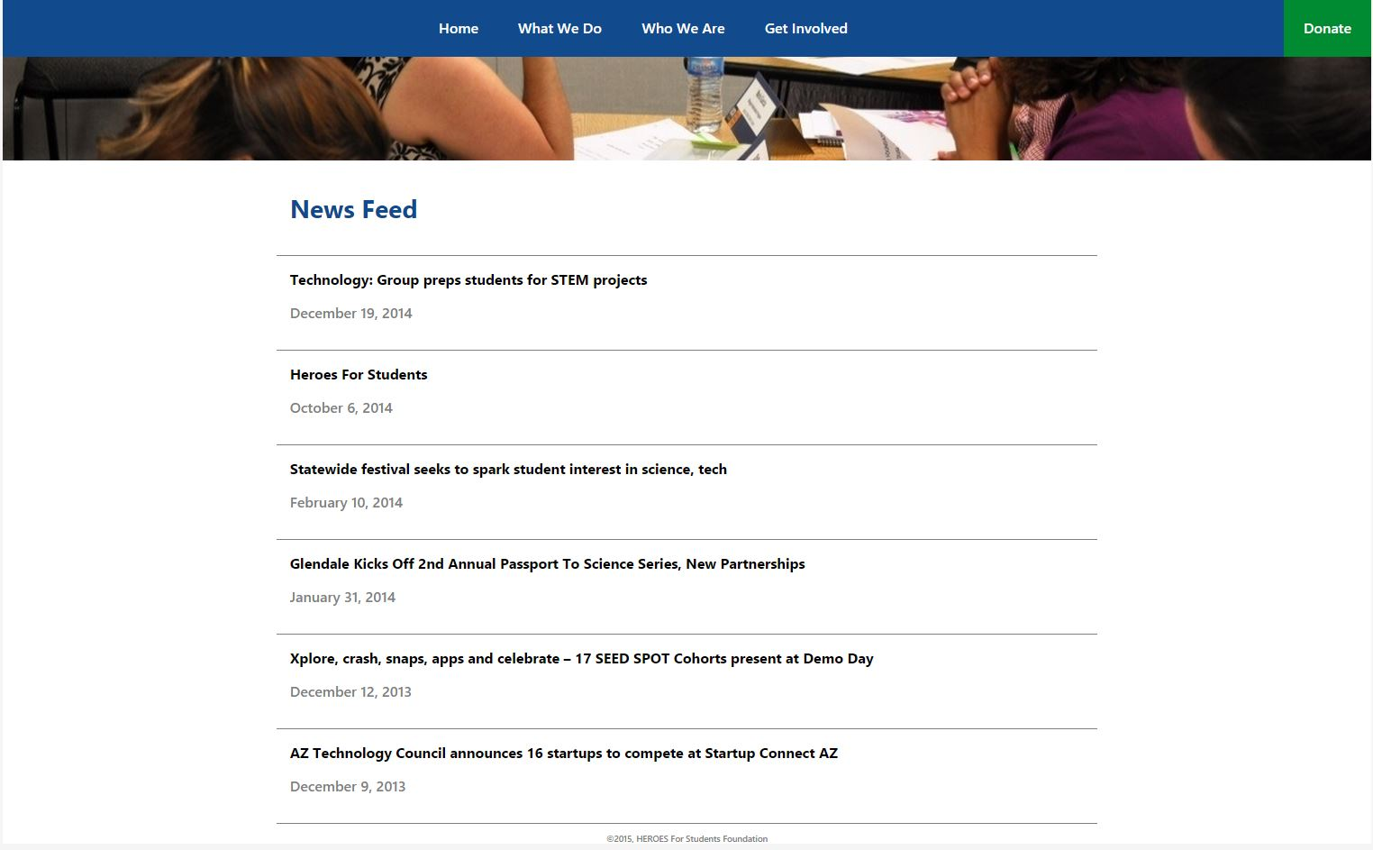

What We Do Page (the 2 photos contain videos when clicked on)

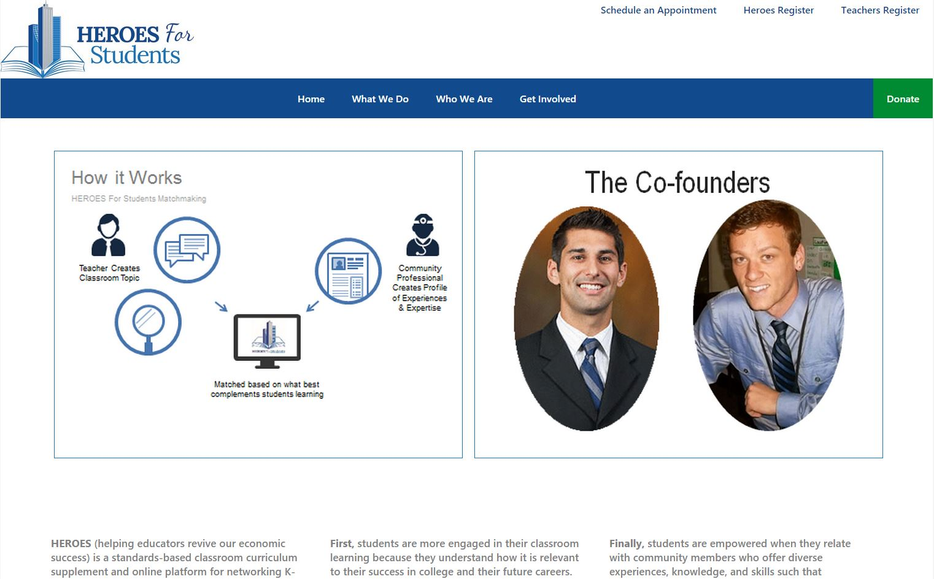

What We Do text

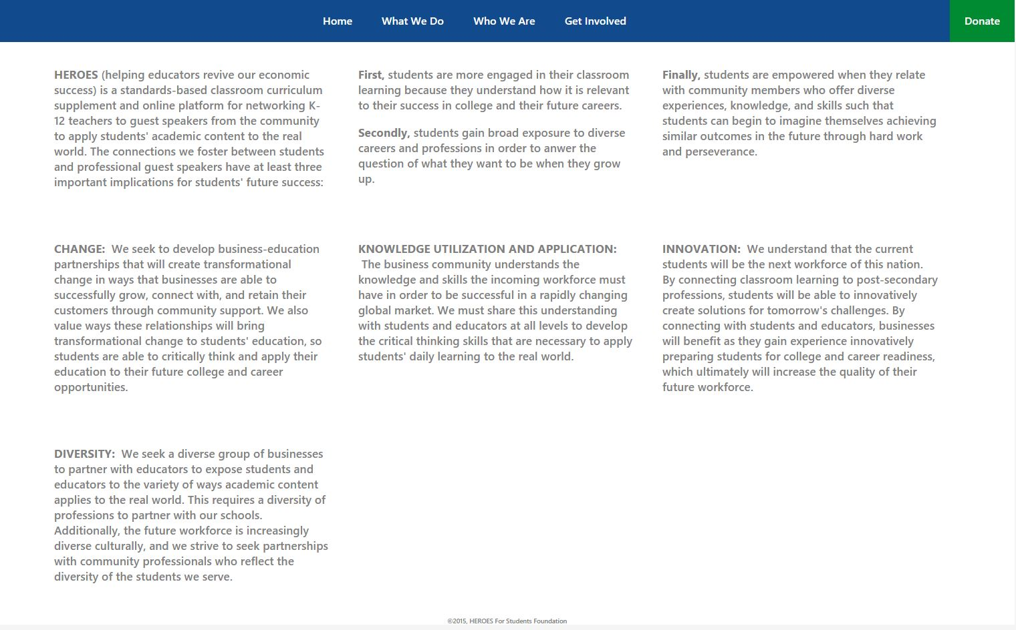

What We Do(Animation Video)

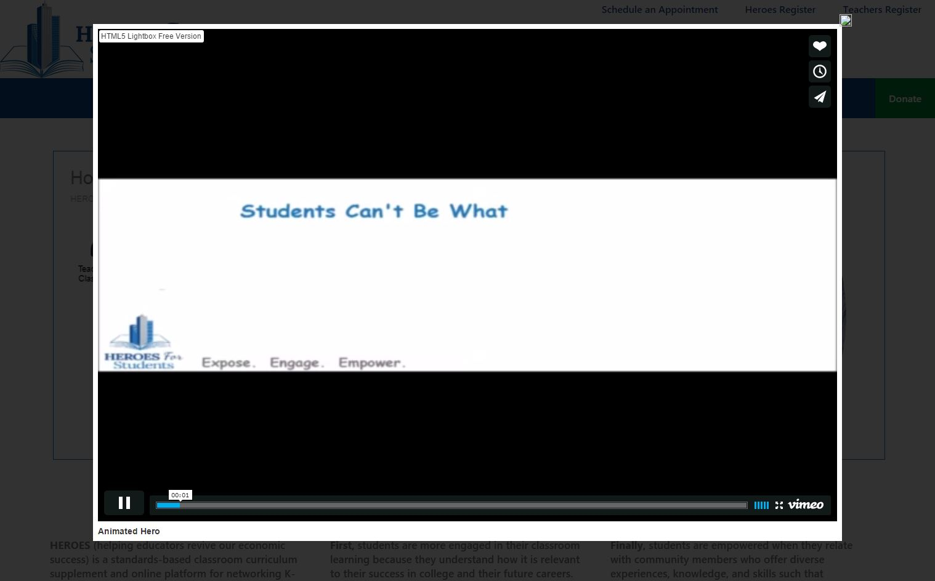

What We Do(About HEROES video)

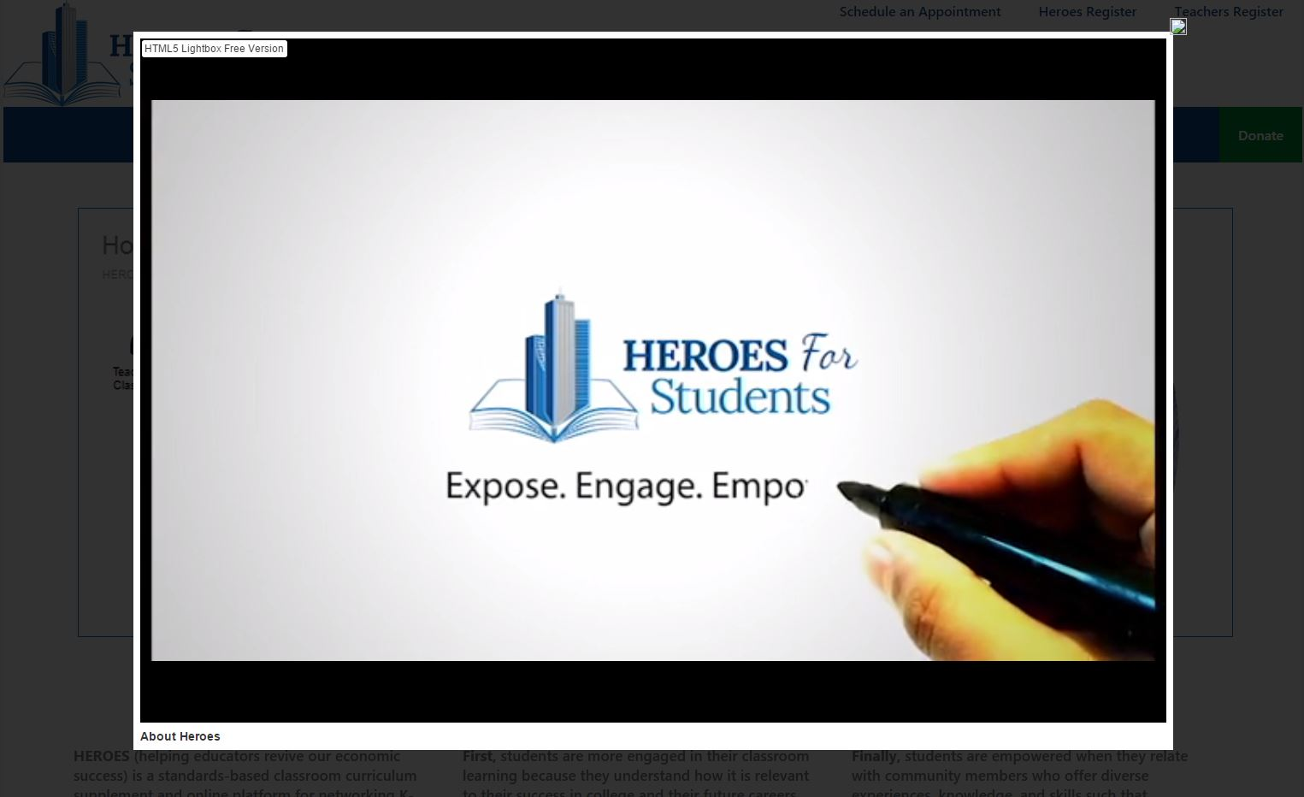

Who We Are(Co-Founders)

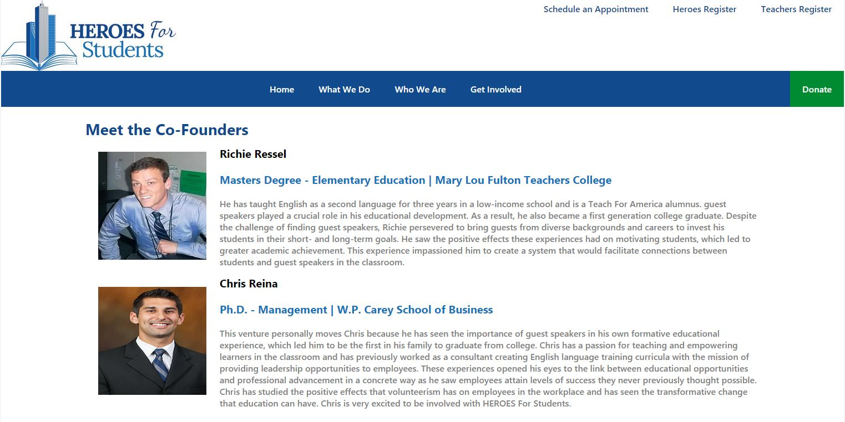

Who We Are(Board of Advisors)

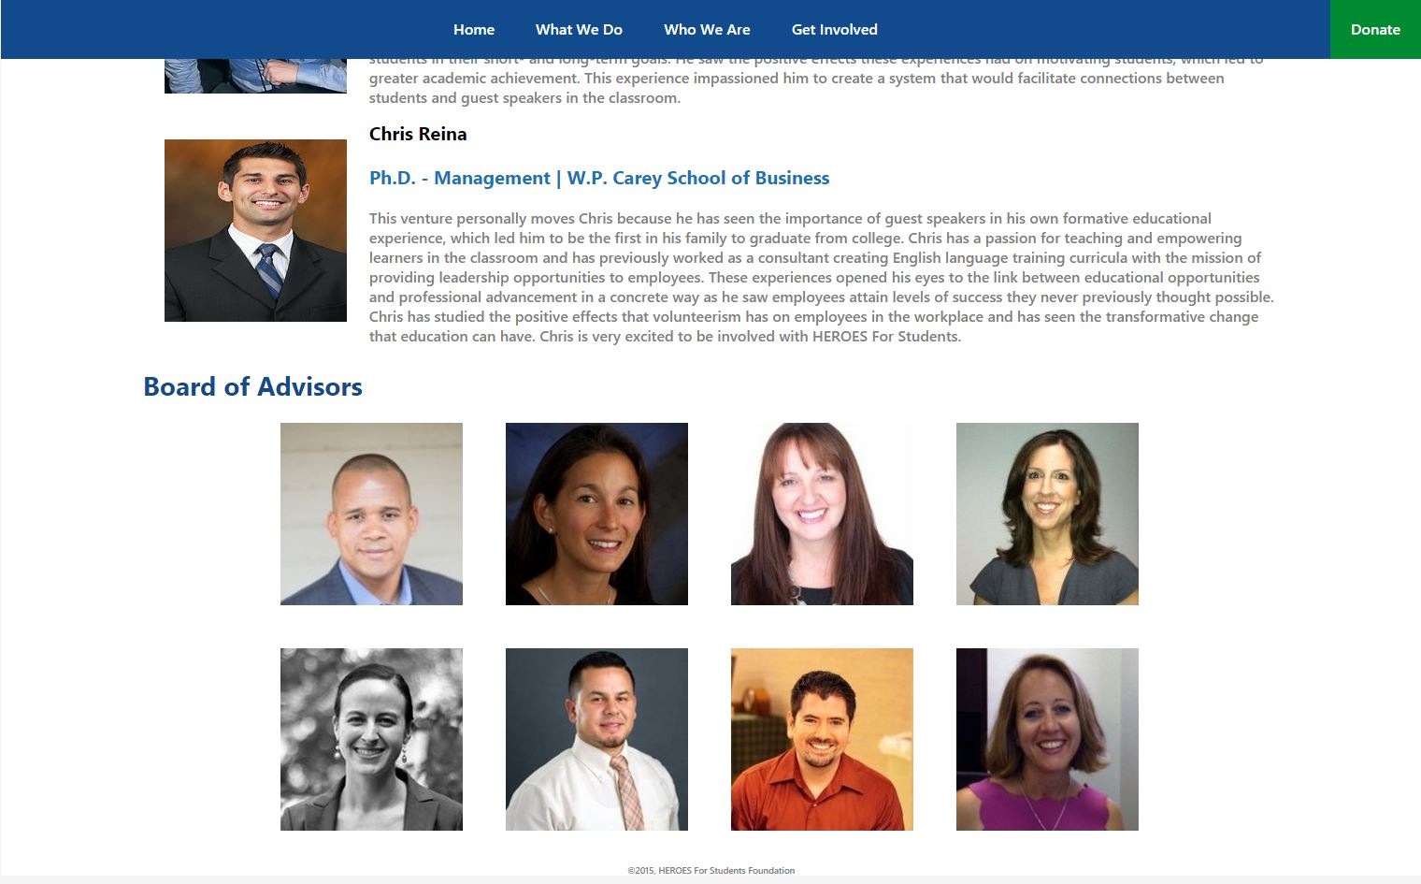

Get Involved page

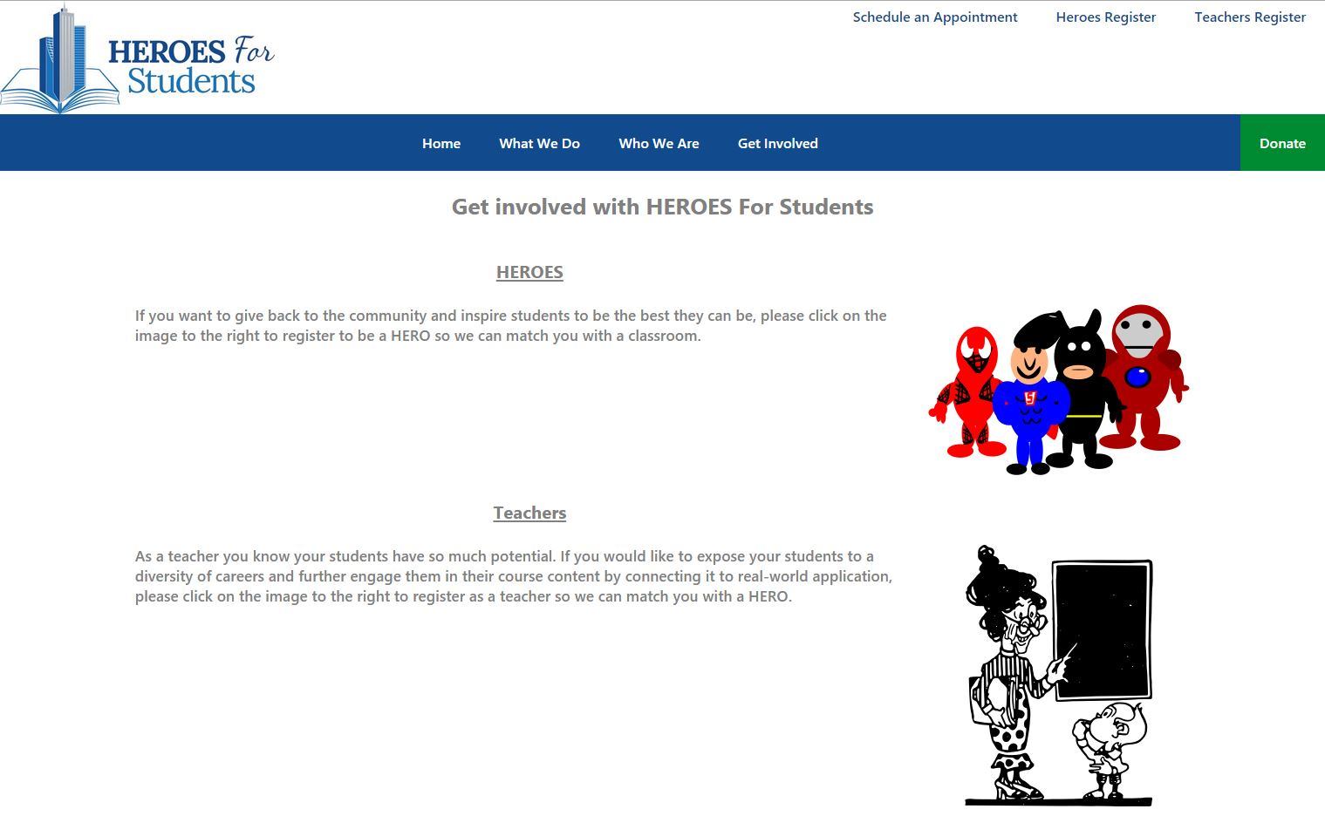

Get Involved page

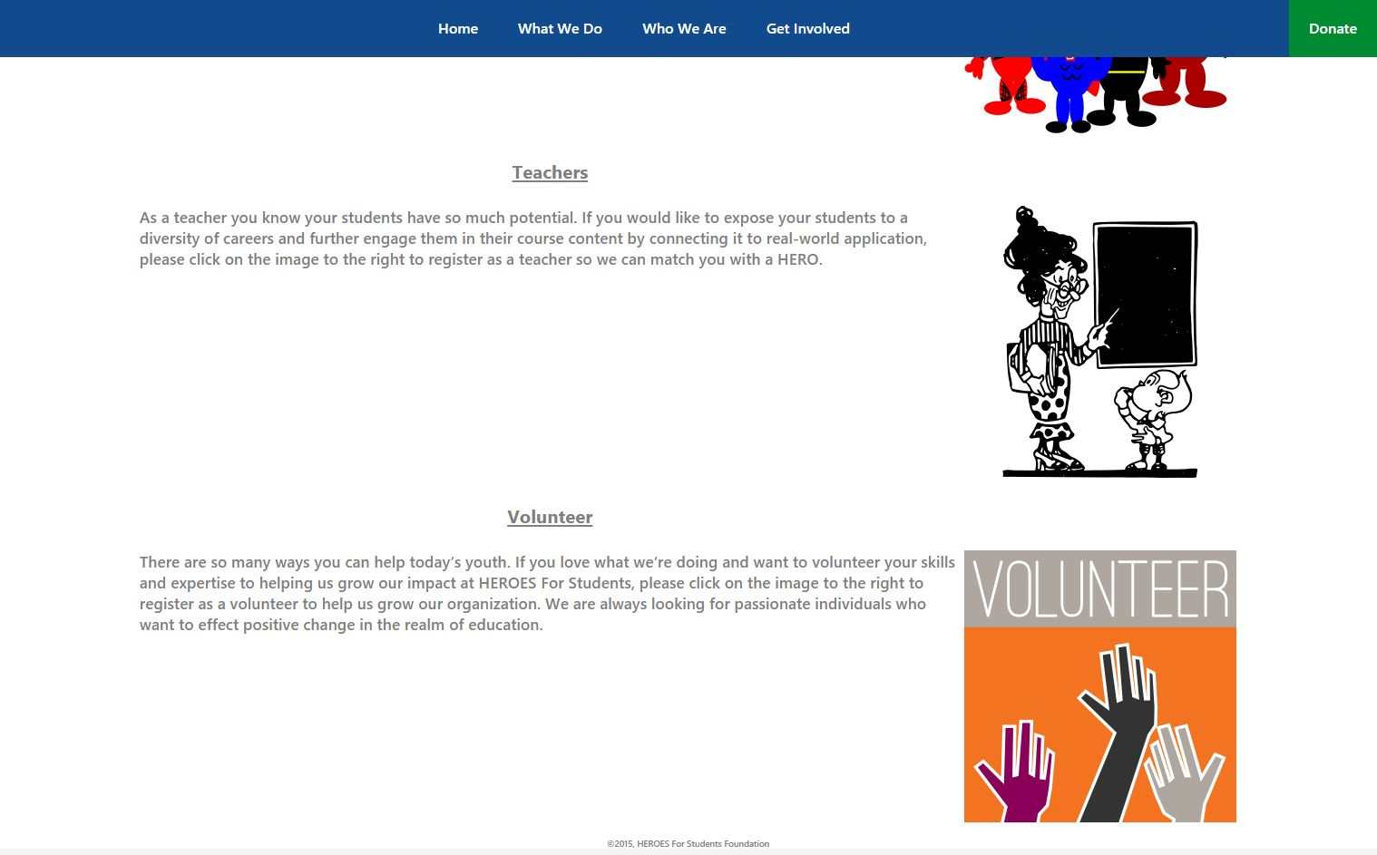

Schedule an appointment with TimeTrade

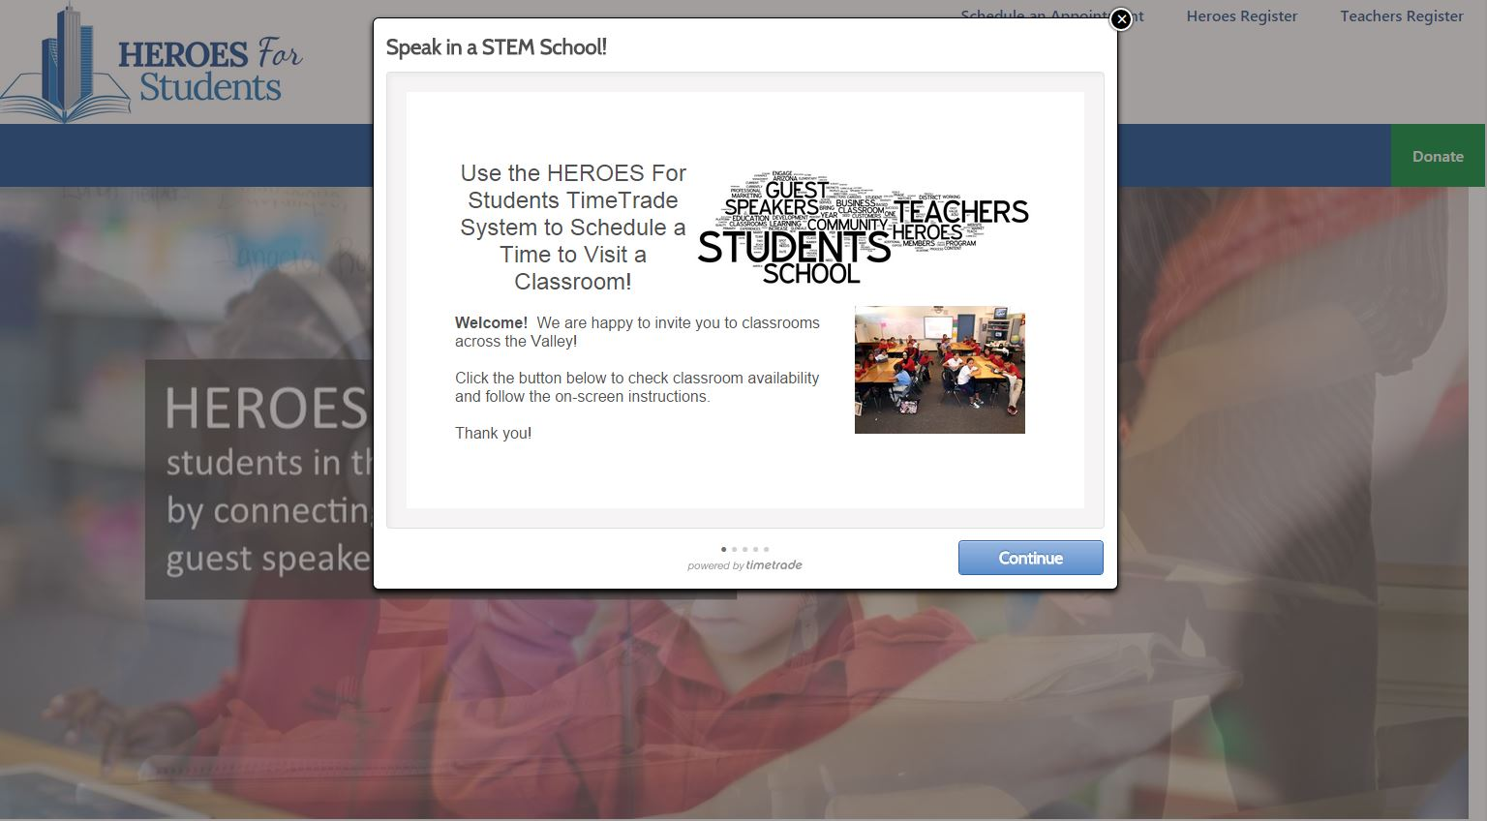

GitHub

For our project we used GitHub. GitHub is a web-based repository hosting service. It offers distributed revision control and source code management functionality. It also has other features such as access control and several collaboration features like wikis, task management, and bug tracking. We used it primarily as a repository. All team members uploaded code as it was completed, and all our milestones were submitted by creating commits. Other teams we able to view our code and make suggestions or changes as well. Below is an image showing some of the files that were uploaded to our repository.

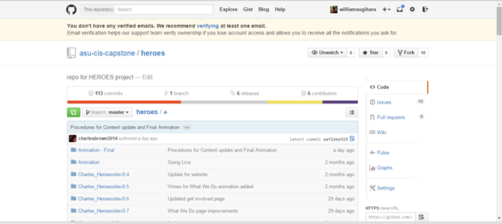

Conclusion

In this report for the HEROES For Students Foundation website re-design, we have introduced our client and briefly described their mission regarding their organization. Additionally described is the website’s previous layout and code structure and the concerns our group had with the project as a whole. Each milestone and our improvements to the website at each stage of our project is also discussed. Added features such as our slideshow, timetrade scheduling, new donate page, and general as well as JavaScript styling features have been implemented and are functioning well according to our client’s needs and feedback. Though these features have been implemented smoothly, there are some additional features that will additionally improve the website if a future project is proposed

Extra features that the HEROES For Students Foundation website include a login feature, Linkedin compatibility feature, and, if the client decides, and upgrade to their database management system. If a future project is introduced, a login and register feature where teachers and HEROES may register using their Linkedin profile would be an excellent improvement to the site. Our site would be able to scrape information from the user’s Linkedin profile and add it to the register form. Additionally a remodel of their database may also be a significant improvement to their site. Though our client likes the simplicity of our Google Forms registration method, for security reasons, using a database management system such as mySQL would be greatly beneficial.